|  |
| --- |
| University of Canterbury |
| Generating Power for Remote Applications in Extreme Environments |
| ENEL427 |
|  |
| **Nathan M. Rich** |
| **/2011** |

|  |
| --- |
|  |

# Abstract

This document provides a template and guidelines for students preparing final project reports for the Third Professional Year Project. Instructions within this document should be adhered to closely. *Excluding title page, abstract page, references and any appendices*, the maximum page limit is **15 pages**. This limit may not be exceeded. Appendices are for additional background material and are **NOT** to be used as a place to extend the report and avoid the page limit. A penalty schedule applies for reports which do not fall within the guidelines as presented in this paper.

The abstract must be placed on its own page, which should be numbered page 1 at the bottom centre of the page. The abstract is limited to 250 words, but should be at least 50 words in length. No table of contents is needed, nor should one be included. Begin the introduction on page 2.

# INTRODUCTION

Around the world there are many extreme environments in which conventional battery power is not suitable for powering devices due to the fact that one has to replace the battery when it runs out and the environment does not easily allow for this. Getting rid of conventional battery power essentially means creating a self-powered device.

Extreme environments can have temperatures ranging from -30 to 2000 ̊C with extremely high or low pressures. To design a device that can generate power for some application and withstand the environment is the challenge of this project. Of benefit is the environment itself as high temperatures and pressures can be used to generate power because there is an abundance of it in the extreme environment.

In this project the extreme environment chosen is the undersea environment. Under the sea the temperature can range from 3 to 21 ̊C (Anthoni, 2006) and the pressure increases one atmosphere per ten metres of depth under water (Zabel, 2006). Thus the solution must be able to handle these temperatures and generate power.

The specific tasks of this project are to investigate an extreme environment, find a suitable way to power a device and then to design a solution. The goal upon completion is to have a well thought out design that could be built and used in the real world.

As an example of the possible applications of such a device, a small robot that crawls along the ocean floor either videoing what it finds or testing ocean floor sediments shall be the focus of this solution.

# CHOICE OF POWER GENERATION

Given that the extreme environment was the undersea environment the first task was to choose a method of power generation. Research was done via the internet looking into the characteristics of the sea and trying to identify ways to exploit the environmental characteristics, see appendix 1. Four different possible ways of generating power in the sea were considered and the following information was found.

### Pressure

High pressure is one of the extreme environmental elements of the sea for which this project was chosen. Thus it makes sense to try exploit this characteristic as there is virtually no limit to its supply. In exploiting it one would also have to think of any environmental impacts it might have.

From the research done it was found that to create energy from pressure one must obtain a differential however small. In the sea environment there is high pressure but there is not a differential. There were two ways that were thought of to obtain a differential; the first was by having two devices with one much deeper than the other as it is known that the pressure increases the deeper down an object is. Thus the two devices have different pressures and a differential is found. The disadvantage to this though is that the whole solution would have to be rather large and would therefore not be very helpful on moving objects and would be more prone to damage from sea creatures. The second way that was thought of to create a differential was to use the undersea currents which would press against a plate creating a differential. This technology is in fact already been in use in the form of hydrophones (Wilson, 2005) and uses piezoelectric technology.

### Temperature

A low temperature is the other environmental extreme of the sea and so it makes sense also to try exploiting this. However as with pressure a differential in temperature is needed. The only way hypothesized to create such a differential was to once again have two devices at different depths so that different temperatures are found. However since this is the same solution as before it has the same disadvantages.

### Chemical

### Kinetic

The solution of using the pressure of currents to create a pressure differential was the best solution found thus far however glaring problem was that the current would push the device very heavily when contacting the plate. Another solution that solves this problem is actually a lot simpler than the piezoelectric technology although not as exciting; a turbine. Using a turbine would allow water to flow through the device generating the power but not being pushed as much by the current.

### Decision

Given the options above, the method of power generation was decided to be kinetic utilizing a turbine to harness the power of undersea currents.

# SPECIFICATION

The final design must create a robot that can handle the environment around it. This means the robot must resistive to corrosion especially by rust given that it is in salt water. The robot must also be able to handle the temperature which is believed to be anywhere between 3 to 21 ̊C (Anthoni, 2006). In addition there is also a pressure element that will increase one atmosphere for every ten metres of the depth underwater the robot is submerged in (Zabel, 2006). The said conditions are the specific conditions that the robot must deal with underwater. In addition to these are the more usual ones that the robot must be extremely reliable with its own power source and be able to move around under water.

However in order to create a robot design in the space of time given it was decided to make simplifications to the robot design that could be rectified in the future once the initial design was proven. For example the robot design given gives no ability to turn or maneuvre around difficult obstacles. The robot also has no remote control feature, that is the robot simply moves forward when given power and waits otherwise. The robot also does not have the features that would make it useful such as sediment testing facilities or an onboard video camera, these features were intended to be added once the robot has proven the ability to harvest and put to use power from passing currents.

# THEORY OF OPERATION

### Overview

A relatively simple design has been produced and a block diagram of it is shown in Fig 1.



Figure 1. System Block Diagram

### Turbine

In order to harness the power of the passing currents a turbine is attached to the top of a small robot. As a starting point this turbine will be in a fixed position, that is, it will not be able to rotate in order to maximize the power. The size of the turbine is governed by the amount of power required. The output motor chosen to power the wheels of the robot requires 5V and 1A when running and there shall be two motors; one powering the back wheels and one powering the front wheels. This means that a total of 10W of power will be required at the output not including any extra features the robot might incorporate. Assuming other features might need up to 10W, the total output power becomes 20W, finally assuming the power converter to be about 80% efficient the input power will need to be at least 25W.

Using the following equation for power from a water turbine (Kirke, 2005):

$$P_{elec}=\frac{ηρAV^{3}}{2}$$

The efficiency of the turbine is assumed to be = 0.3 given the Betz Limit of 0.6 and the density of water to be 1024kg/m3 (Polagye, 2009).

$$25=0.3×1024×π×{\left(\frac{d}{2}\right)}^{2}×V^{3}$$

V is velocity, about 3 knots = 1.54 m/s (Statnikov, 2002)

$$25=0.3×1024×π×{\left(\frac{d}{2}\right)}^{2}×{1.54}^{3}$$

$$d=0.168$$

Therefore the diameter of the turbine needs to be at least 16.8 cm.

### Gearbox

Since the

### Generator

The generator chosen was the Scorpion S-4025-16, which is a 3 phase delta wound motor (Scorpion, 2011). The motor was said to work at 17.5V and have a continuous output of 2 kW; however when tested as a generator these figures were found to be around 5V with a continuous output of only 70W as shown in the testing section of this report. However as only 25W is needed the generator is to spun at approximatelyThis generator was chosen not for optimization of design but for optimization of cost as the generator was already in the department and hence could be used free of charge.

### Power Converter

The power converter takes the power from the generator and transforms it into an output suitable for the wheel motors. The power converter must convert the 5V, 2A AC wave into a 5V, 2A DC waveform. Many power converter solutions are available so it is important to look at characteristics that will narrow the selection. As the only outputs are the two motors no isolation is required, and thus a three phase rectifier bridge consisting primarily of 6 diodes is used to transform the 3 phase AC to single phase DC. A small amount of DC bus capacitance is then required to filter the waveform. After that a buck-boost DC-DC converter will be used to step up or down the voltage depending on the voltage at the time.

### Output Motors

The output motors aims to take the power from the power converter and use it to power the wheels which give the robot the ability to move. The motor chosen, like the generator, was chosen as available on hand. It is the RE-540 made by Como Drills and it has 4.5 - 15V and 1A running characteristics (Como-Drills, 2011). In order to give the robot traction in most situations the robots shall be four wheel drive and hence two identical output motors shall be put in parallel, one for the front wheels and one for the back. Having the motors in parallel will also decrease the resistance seen by the generator which will increase the power output as seen in the testing section of this report.

### Wheels

In order to get traction in the soft undersea sediment, large spiked wheels with attached tank tracks have been chosen. The use of tank tracks will also distribute the weight of the robot over a large area to reduce the chances of sinking.

### Undersea Challenges

Given that water conducts electricity is it imperative that no water can get into the electronics of the robot. This means that the robot must be completely water tight. However at depth undersea the atmospheric pressure has increased one atmosphere for every ten metres underwater (Zabel, 2006). This means that if the robot is filled with air it is likely to be crushed as air compresses under pressure. For this reason the robot should be filled with an incompressible liquid that is also non-conducting. Oil is a perfect choice as it fulfills both these requirements and is relatively easy to obtain. In terms of the build stage, this means that the robot should be submerged in an oil bath as the casing is sealed. In this way the robot can be sure to have no air in it.

### Design Concept

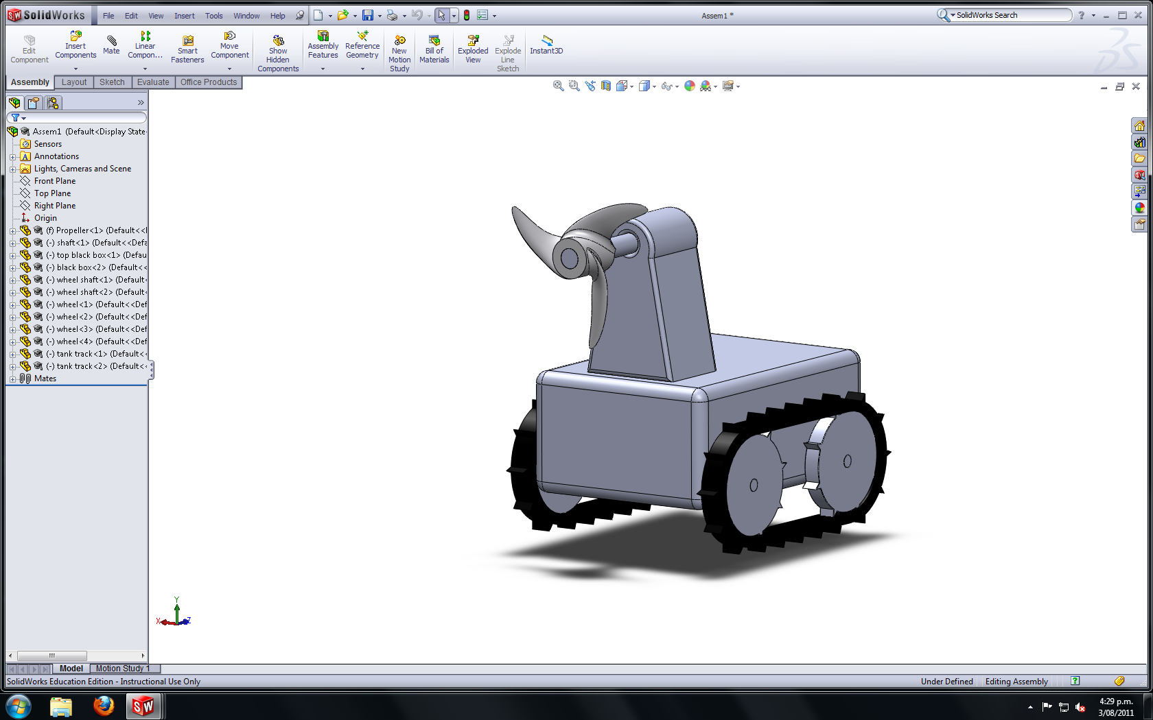

Figure 2. Artist's view of completed robot

# COST/CONSTRUCTION

|  |  |
| --- | --- |
| Item | Cost |
| Generator | Free |
| Motor (x2) | $51 (RS-Components, 2011) |
| Turbine | $25 (APC, 2009) |
| Tank tracks and wheels | $50 |
| Enclosure | $50 |
| Oil | $10 |
| Total |  |

To avoid rust, the robot will be made of plastic wherever possible. That is the enclosure, turbine, wheels and tank tracks will all be plastic. This leaves the only metal parts to be the generator, the motors, and the power converter; however these components will be enclosed in oil and as such should not be at risk of rust.

In building the robot extreme care must be taken when sealing the oil filled enclosure. To ensure no air bubbles it is envisioned that the sealing of the enclosure will be done in an oil filled tub.

# TESTING

Before building electrical devices, the testing of key components must occur. In this case the key component is the generator as the characteristics of it will determine the specifics of the power converter part of the design. To determine the characteristics of the generator, the generator was set up with a variable resistive load attached to each phase and the voltage and current were measured through one phase. The generator was then spun using a mechanically attach dynamometer as shown in. The following measurements were taken and then graphed in Fig 2.

Table 1. Voltage and Current Testing of the Generator at 5Ω per phase

|  |  |  |  |  |
| --- | --- | --- | --- | --- |
| Per Phase Resistance 5Ω | | | | |
| Speed | Current (A) | Voltage (V) | Power (W) [=I2R*3] | |
| 0 | 0 | 0 | | 0 |
| 200 | 0.046 | 0.761791 | | 0.032 |
| 400 | 0.084 | 1.273735 | | 0.106 |
| 600 | 0.114 | 1.842016 | | 0.195 |
| 800 | 0.142 | 2.427444 | | 0.302 |
| 1000 | 0.170 | 3.076559 | | 0.434 |
| 1200 | 0.193 | 3.639942 | | 0.559 |
| 1400 | 0.214 | 4.227819 | | 0.687 |
| 1600 | 0.236 | 4.825495 | | 0.835 |
| 1800 | 0.255 | 5.410923 | | 0.975 |
| 2000 | 0.275 | 6.030644 | | 1.134 |
| 2200 | 0.292 | 6.608723 | | 1.279 |
| 2400 | 0.308 | 7.174555 | | 1.423 |
| 2600 | 0.323 | 7.757534 | | 1.565 |
| 2800 | 0.337 | 8.347861 | | 1.704 |
| 3000 | 0.351 | 8.906345 | | 1.848 |
| 3200 | 0.363 | 9.445232 | | 1.977 |
| 3400 | 0.376 | 10.05516 | | 2.121 |
| 3600 | 0.387 | 10.61609 | | 2.247 |
| 3800 | 0.397 | 11.12068 | | 2.364 |
| 4000 | 0.408 | 11.66937 | | 2.497 |

Table 2. Voltage and Current Testing of the Generator at 1Ω per phase

|  |  |  |  |
| --- | --- | --- | --- |
| Per Phase Resistance 1Ω | | | |
| Speed | Current (A) | Voltage (V) | Power (W) [=I2R*3] |
| 0 | 0 | 0 | 0 |
| 200 | 0.22 | 0.7177 | 0.145 |
| 400 | 0.444 | 1.227194 | 0.591 |
| 600 | 0.665 | 1.797925 | 1.327 |
| 800 | 0.862 | 2.358859 | 2.229 |
| 1000 | 1.060 | 2.939388 | 3.371 |
| 1200 | 1.249 | 3.524816 | 4.680 |
| 1400 | 1.422 | 4.066153 | 6.066 |
| 1600 | 1.599 | 4.661379 | 7.670 |
| 1800 | 1.762 | 5.239459 | 9.314 |
| 2000 | 1.922 | 5.817538 | 11.08 |
| 2200 | 2.075 | 6.390719 | 12.92 |
| 2400 | 2.215 | 6.981046 | 14.72 |
| 2600 | 2.365 | 7.593418 | 16.78 |
| 2800 | 2.496 | 8.178846 | 18.69 |
| 3000 | 2.619 | 8.720183 | 20.58 |
| 3200 | 2.750 | 9.349702 | 22.69 |
| 3400 | 2.860 | 9.905737 | 24.54 |
| 3600 | 2.986 | 10.54995 | 26.75 |
| 3800 | 3.093 | 11.12558 | 28.70 |
| 4000 | 3.189 | 11.66692 | 30.51 |

Table 3. Voltage and Current Testing of the Generator at 5Ω per phase

|  |  |  |  |
| --- | --- | --- | --- |
| Per Phase Resistance 0.5Ω | |  | |
| Speed | Current (A) | Voltage (V) | Power (W) [=I2R*3] |
| 0 | 0 | 0 | 0 |
| 200 | 0.389 | 0.489898 | 0.227 |
| 400 | 0.795 | 1.036134 | 0.948 |
| 600 | 1.186 | 1.579921 | 2.110 |
| 800 | 1.579 | 2.128607 | 3.740 |
| 1000 | 1.970 | 2.68954 | 5.821 |
| 1200 | 2.353 | 3.26517 | 8.305 |
| 1400 | 2.708 | 3.799159 | 11.00 |
| 1600 | 3.060 | 4.338046 | 14.05 |
| 1800 | 3.418 | 4.903878 | 17.52 |
| 2000 | 3.759 | 5.452564 | 21.20 |
| 2200 | 4.092 | 5.996351 | 25.12 |
| 2400 | 4.460 | 6.584228 | 29.84 |
| 2600 | 4.780 | 7.132914 | 34.27 |
| 2800 | 5.100 | 7.691398 | 39.02 |
| 3000 | 5.410 | 8.230286 | 43.90 |
| 3200 | 5.720 | 8.769173 | 49.08 |
| 3400 | 6.000 | 9.327657 | 54.00 |
| 3600 | 6.280 | 9.84205 | 59.16 |
| 3800 | 6.560 | 10.38584 | 64.55 |
| 4000 | 6.840 | 10.87084 | 70.18 |

Figure 3. Plot depicting the relationship between current and voltage for the generator depending upon the resistance per phase.

Figure 4. Plot depicting the relationship between the total power and voltage for the generator depending upon the resistance per phase

# DISCUSSION

### Generator Results

From Table 1 it is clear that the generator produces more current for a smaller resistance and given that power is $P=I^{2}R$, the smaller the resistance, the more current and the more power. This means it is a much better idea to parallel the two output motors rather than have them in series as it will decrease the overall resistance and hence increase the power.

Given the results of the generator we can see that the output power ranges from 0 to 70W for resistance of 0.5 - 5Ω and speeds of 0 – 4000rpm. This is well above the required 25W, and hence the generator need only spin at around 1000rpm for a resistance per phase of 0.5Ω.

### Future Steps

Following the work done in this report the next step in the design process would be to build the robot itself. This would mean at the very least having the bottom part of the robot complete, that is everything except the turbine and generator mounted on top.

From this a motor could be chosen, purchased and then tested using a variable wall supply to find exactly what voltages and currents would be needed to create movement from the tank tracks.

Once these characteristics were confirmed the power converter could be chosen and purchased. Once done the next step would be to test the power converter using a wall supply to simulate the expected output from the generator, which would confirm that the correct output characteristics were being given to the output motor. The output motors would then be connected and the tank tracks would run. Once this part of the system is seen to work properly the turbine and generator would be mounted. The robot would then be tested using the dynamometer to turn the generator and a success would be indicated by the tank tracks turning. The final step then would be purchase a turbine and gearbox that would spin the generator and the correct speed.

Finally testing would occur underwater checking that the device was indeed watertight and last of all a water tunnel would need to be constructed to simulate a current passing through.

# CONCLUSIONS

# REFERENCES

Anthoni, J. F. (2006). *Composition of Sea Water*. Retrieved April 2011, from Seafriends: http://www.seafriends.org.nz/oceano/seawater.htm

Como-Drills. (2011). *Miniature DC Motors.* Retrieved August 2011, from MFA/Como Drills.

Kirke, B. (2005). Retrieved July 2011, from Cyberiad: http://www.cyberiad.net/library/pdf/bk_tidal_paper25apr06.pdf

Polagye, B. L. (2009). *Hydrodynamic effects of kinetic power extraction by in-stream tidal turbines.* University of Washington.

RS-Components. (2011). *Motor,35.7mm dia,15Vdc,RE540/1,3 pole*. Retrieved August 2011, from RS Components: http://newzealand.rs-online.com/web/search/searchBrowseAction.html?method=getProduct&R=2389759

Scorpion, P. S. (2011). *Scorpion S-4025-16*. Retrieved July 2011, from Scorpion Power Systems: http://www.scorpionsystem.com/catalog/motors/s40/S-4025-16/

Statnikov, E. (2002). *Speed of Ocean Currents*. Retrieved July 2011, from The Physics Factbook: http://hypertextbook.com/facts/2002/EugeneStatnikov.shtml

Wilson, J. S. (2005). *Sensor Technology Handbook (Vol 1).* Newnes.

Zabel, M. (2006). *Marine Geochemistry.* Birkhauser.